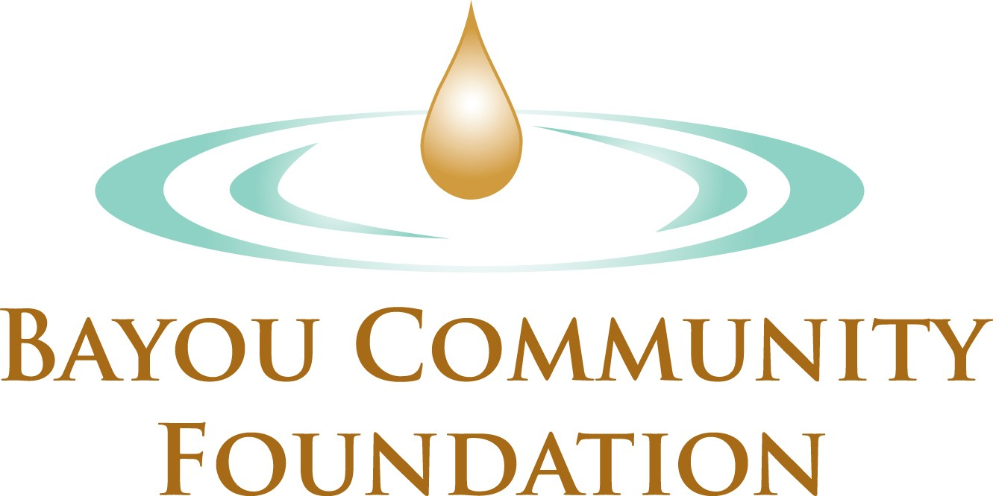

GIVING BACK. GROWING STRONGER. TOGETHER.
GIVING FORM

Name

Company/Organization

Address

City/State/Zip

Phone Email

I wish to make an enclosed gift of (please circle):
$10,000 $5,000 $1,000 $500 $100 Other ______________

My gift is a memorial donation in memory of

Please send a memorial card to: (name and address) ______________________________________________________________

I do not wish to have my name published as a donor.

Please direct my gift toward the following BCF Fund:
Bayou Community Foundation Fund – supports all BCF work to strengthen our community
BCF Grants Fund – supports annual grants to Lafourche, Terrebonne and Grand Isle nonprofits
Bayou Recovery Fund– supports disaster relief and recovery efforts with grants to local nonprofits and other direct relief and recovery services
BCF Quasi-Endowed Fund – your initial gift remains with BCF in perpetuity, while the interest supports BCF grants and other programs

Mail form and check to:
Bayou Community Foundation • P.O. Box 582 • Houma, LA 70361
or Give Online with Credit Card at www.BayouCF.org
1% of gifts to Grants Fund or Bayou Recovery Fund is reserved to administer grants programs.

The Bayou Community Foundation is a 501c3 public charity.

Your contributions qualify for the maximum deductions allowed by law for charitable donations.

Contact us for information about gifts of stocks, securities, IRA distributions, insurance, bequests, and trusts.

Jennifer Armand, Executive Director – ArmandJ@BayouCF.org (985) 790-1150

